**Assignment 2.1**

1. **Task 1:** Creating Hadoop folder under /user/acadgild in HDFS

Using the command ***Hadoop fs –ls /user/acadgild*** we first check if any folder name Hadoop exist.

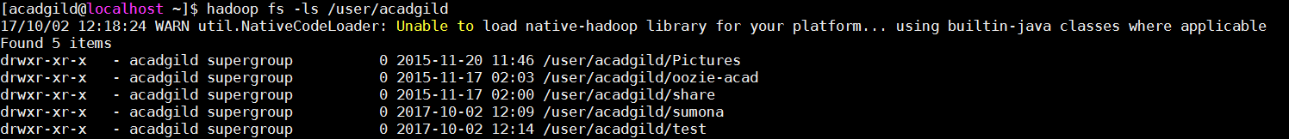

Using the command ***Hadoop fs –mkdir /user/acadgild/Hadoop*** created the **Hadoop** folder under /user/acadgild. After creating the folder, we use the **Hadoop fs –ls** command to check if the directory is created.

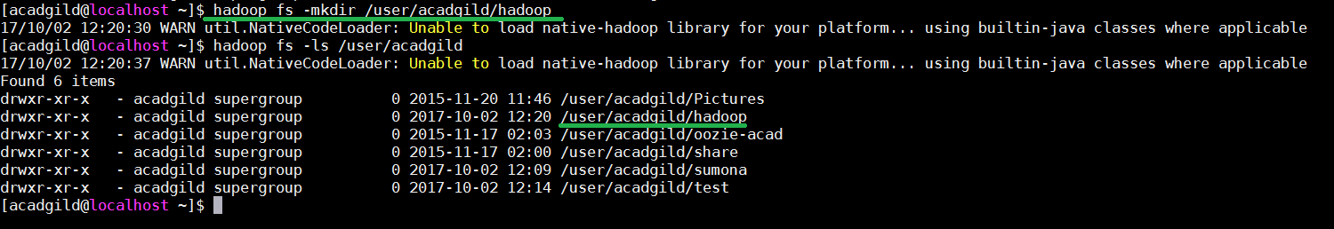

1. **Task 2:** Create a file word-count.txt in HDFS

The command ***touchz*** is used to create a file under a directory.

Usage: **Hadoop fs –touchz /user/acadgild/Hadoop/word-count.txt**

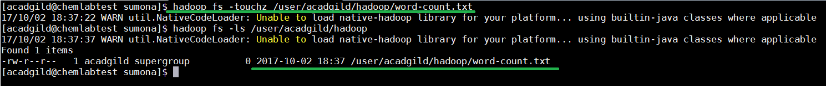

Using the command **–appendToFile** we can type in contents for the file you wish to.

Usage: **Hadoop fs –appendToFile - /user/acadgild/Hadoop/word-count.txt.** To save and close the file, tap **Ctrl+D**



To check the output, we use the command **Hadoop fs –cat /user/acadgild/Hadoop/word-count.txt**

